Problem 7: Albu Maria-Ioana group 911

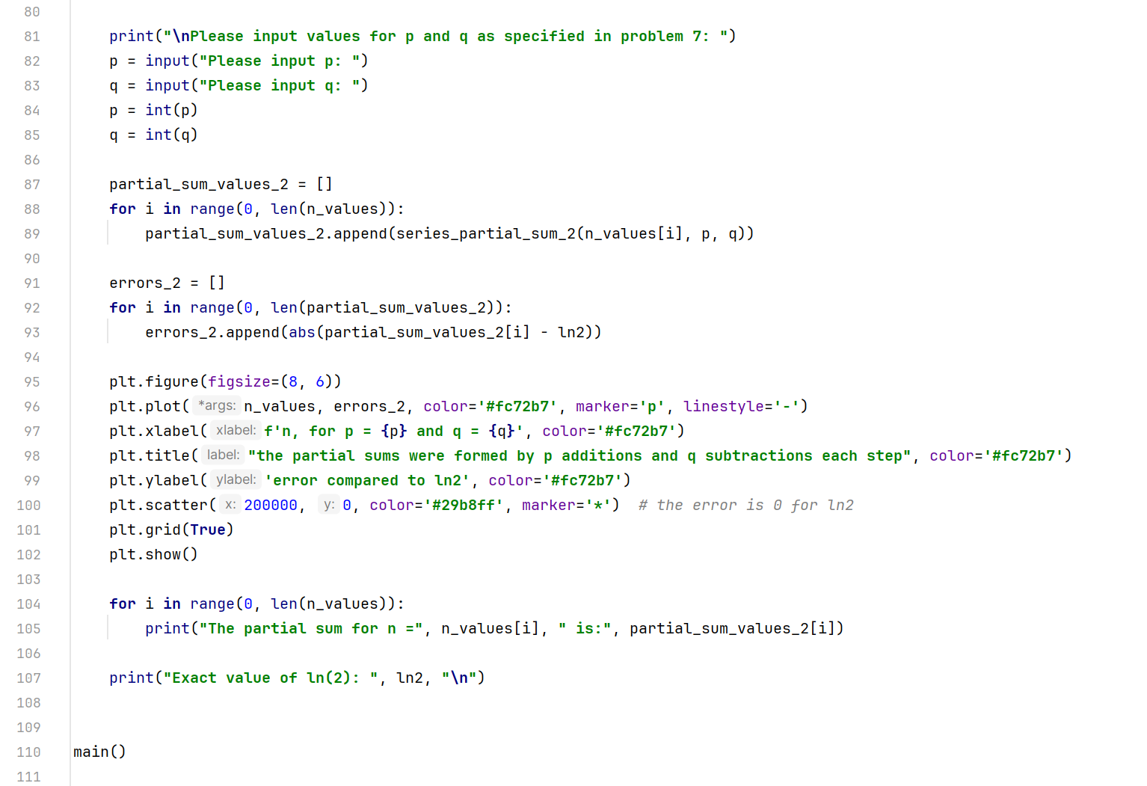

*And here is the output:*

Basically, we can observe that by adding terms using p additions and q subtractions at a time, the value is not as close to ln (2) as it is when adding terms as they are. The error in the second graph is also much larger than the one in the first graph.